How to solve the “duplicate class error” in NetBeans
Sometime we get the message “duplicate class error” in NetBeans, although no such a case occurs, i.e. there are no duplicate classes. We can solve this problem as below:
Go to Help -> About and you will see
Cache directory: Path\to\Directory
Close NetBeans, go to specified directory and delete the index folder inside the cache folder.
Example:
Click on the menu item Help :
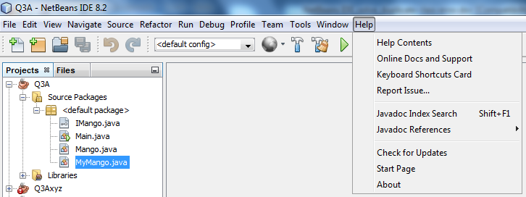
Click on the item About:
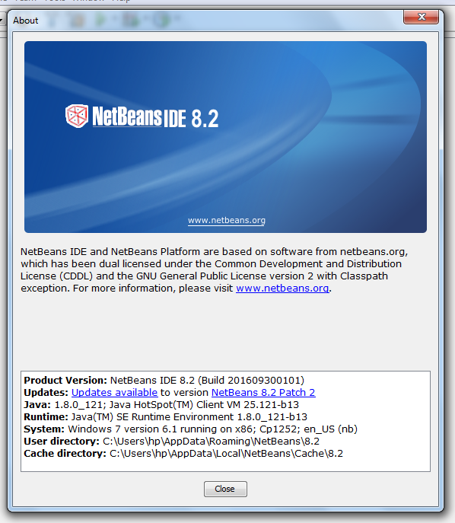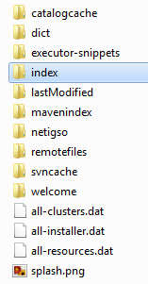
In this case you can see the Cach directory is: C:\Users\hp\AppData\Local\NetBeans\Cache\8.2
Open the folder 8.2 you can see the folder index among many other ones. Delete the Index folder and open NetBeans, then the project having error, you will see that the above error will be gone.

